R Programming Lab Exam

Instruction:

# Task 1

Use R as a calculator to compute the following values.

## 27(38-17)

> 27*(38-17)

[1] 567

## ln(147­)

> log(14^7, exp(1))

[1] 18.4734

## 

> sqrt(436/12)

[1] 6.027714

## initialize variables a = 2, b=1.2, c=a

x <- ((-b) + (sqrt(abs(b^2 - (4*a*c)))))/(2*a)

> x

[1] 0.6539392

$2sinxcosx$

> 2*sin(x)*cos(x)

[1] 0.9656357

## 

> tan(x)/(1 + tan(x)^2)

[1] 0.4828179

# Task 2

Create the following vectors in R.

a = (5, 10, 15, 20, ..., 160)

b = (87, 86, 85, ..., 56)

Use vector arithmetic to multiply these vectors and call the result **d**.

Select subsets of **d** to identify the following.

## What are the 19th, 20th, and 21st elements of d?

> d[19:21]

[1] 6555 6800 7035

## What are all of the elements of d which are less than 2000?

> d[d < 2000]

[1] 435 860 1275 1680

## How many elements of d are greater than 6000?

> length(d[d > 6000])

[1] 16

# Task 3

Using **d** from task 2, use R to compute the following statistics of d:

## Sum

> sum(d)

[1] 175120

## Median

> median(d)

[1] 5897.5

## Standard deviation

> sd(d)

[1] 2608.563

# Task 4



## What is the resulting matrix?

> A%*%B

[,1] [,2] [,3] [,4]

[1,] 61 229 369 565

[2,] 49 163 258 391

# Task 5

Prepare R script that will present given graphs.

## Histogram based on cars dataset

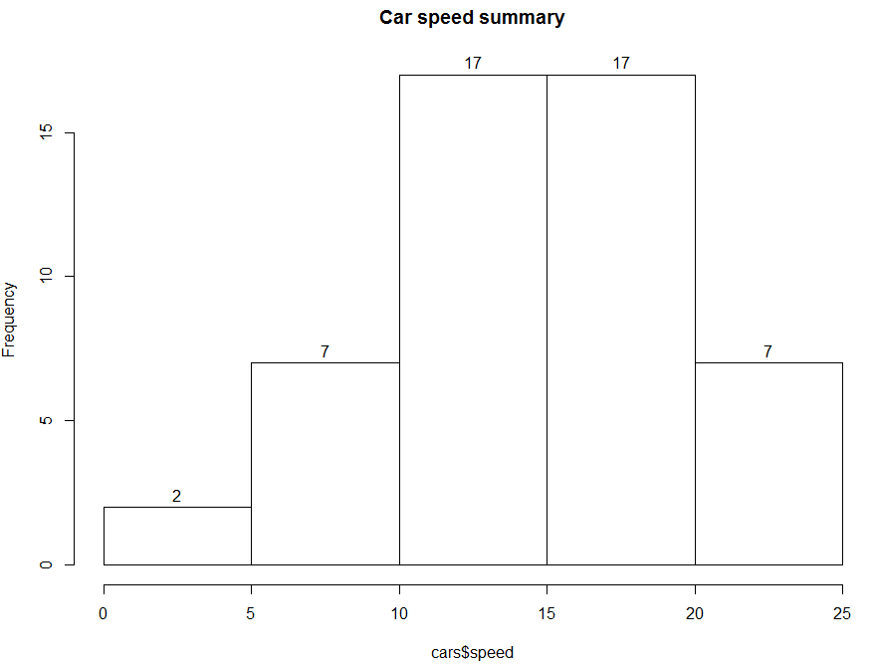

> hist(cars$speed, main = "Car speed summary")

## Boxplot based on Nile

> boxplot(Nile,main="Nile river levels", ylab="levels")

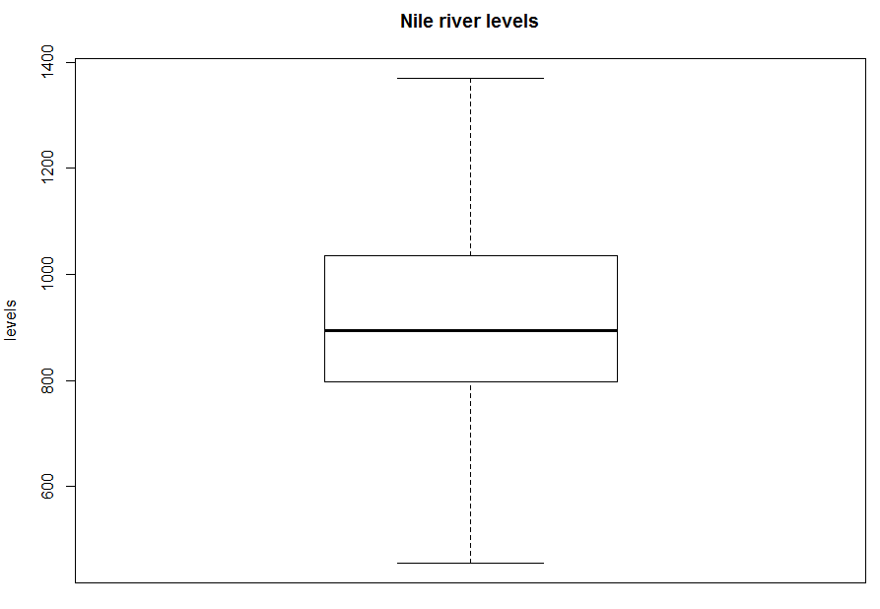

## Plot base on Cars dataset

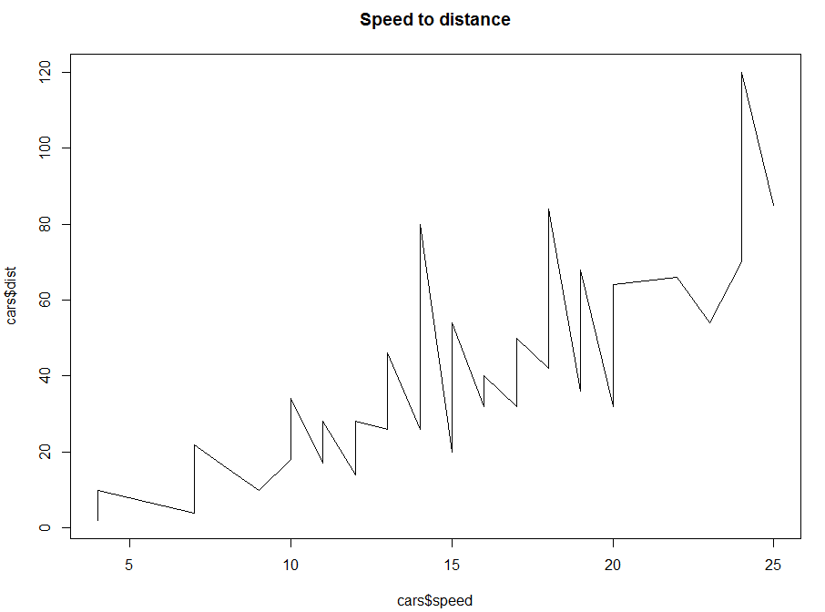

> plot(cars$speed, cars$dist, type = "l", main = "Speed to distance")

Deliver your solution as a word document and upload it to MS Team Platform.